IP Camera

Smartphone -ready colour night/day

network camera with pan, tilt and zoom
DYN-620

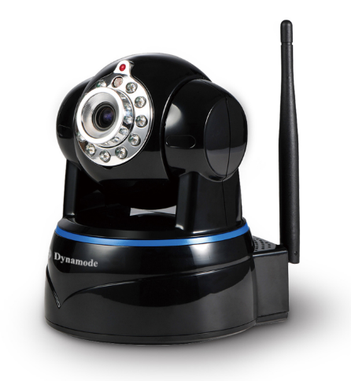
Introduction

The 620GA is the new H.264 2.0Mega Plug and Play indoor PTZ IP Camera. Once you connect camera to internet, no need any setting, you can see anywhere, any place, via Mobile phone/PC/Tablet software to view what you care for!
Grain Media GM8138S chipset;
P2P, Plug and Play;
2.0 Mega IP Camera, 2.0 Mega pixels CMOS lens;
One key wifi setting. No need network cable, use your mobile help IP Camera connect with WIFI.
Support 64G SD card socket for recording storage;
Have Widows PC client and Mac pc client;
620GA +Mobile/Tablet/PC +iSmartViewPro =3 steps Install;
Support 3 kinds of H.264 video stream and 1 way MJPEG video stream; Simultaneously, suitable for Local, Internet and Cross-platform view;
Support resolution for 1920*1080(1080P); 1280*720(720P); VGA; QVGA;
Support 4 ways view in a video stream;
Support 802.11b/g/n protocol, build-in WiFi module to perform wireless monitoring;
Support rotate 290° horizontally and 120° vertically;
Built-in IR_CUT, 4.2 mm lens; 11pcs IR LED, up to 8 meter night vision;
Support 4 times digital zoom;
Support two-way audio; Build-in microphone and speaker, provide the output interface;
Built-in web server, use one port to send all the data, users can facilitates network setting;
Support ONVIF and RTSP protocol, easy to integrate it to NVR or large client software;
Support WPS/QSS function, one key configure wifi;
Support multi-languages web interface, support multi-screen to perform several view at same time;
Provide multi-languages in web interface, PC client software and APPs;
Manufacturer puts a label of DDNS at the bottom of each IP Camera. When IP Camera is connected to the internet, this URL can be used to visit the device;
Provide free client software, support Multi-view, Long time recording, video replay etc;
Support motion detection;
Audio detection and Audio alarm.

Specification
Hardware performance | Product type | IP camera
 | Operation system | Embedded operating system
 | Special function | 2.0 Mega IP Camera; One key WIFI setting; support 64G SD/TF card; have Mac PC client.
Web environment | Web protocol | TCP/IP、UDP/IP、HTTP、SMTP、FTP、DHCP、DDNS、UPNP、NTP、RTSP、ONVIF
 | LAN port | 10Base-T/100Base-TX
 | Wifi | WIFI，802.11 b/g/n
Image performance | Resolution | 1080P; 720P; VGA; QVGA
 | Compression mode | H.264/M-JPEG
 | Max frame rate | 30fps
Other parameters | Lens | f=4.2mm, F=2.0
 | Min. illumination | IR on, 0 Lux
 | Electronic shutter | 1/50s(1/60s)-1/100,000 s
 | SNR | 48db
 | Safety performance | Three levels of user rights
 | Install mode | Wall-mounted/ceiling-mounted
 | Other performance | PC software,support for Microsoft Windows 98/2000/XP/Vista/Windows 7/Mac OS,And the Internet Explorer6.1 and above version or browser compatibility, Firefox, etc.,  provide iSmartViewPro client software
 | Power supply | DC 5V
 | Sensor | 1/2.7’’ CMOS Sensor
 | IP camera performance | Support video control, Two-way voice talkback, motion detection, external alarm(sends information to alarm the server by Email, FTP);  Manufacturers provide free DDNS, and has been written into equipment;  11pcs IR LEDs, 8 meters effectively;  Platform level angle 290 °,120 °vertical angle;  automatically control through the photoresistor;
 | Audio input | Build-in microphone
 | Audio output | Build-in speaker,  provide the audio output interface
 | Alarm in | None
 | Alarm out | None
 | Power consumption | Power<6W
Appearance parameters | Body size | 111*106*124mm
 | Product weight | 0.35kg
Environment parameters | Environment temperature | Operate Temper：-10℃ ~ 50℃  Storage Temper：-40℃ ~ 70℃
 | Environment humidity | Operating Humidity：10% ~ 90%  Storage Humidity：3% ~ 90%

Packing List
1, IP Camera* 1
2, Driver and tool CD *1(OEM customer optional)
3, Quickly installation guide*1
4, RJ45 network cable*1
5, 5V Power Adapter *1
6, Wi-Fi Antenna*1
7, Bracket * 1kit

